Seat Assembly
These seat assembly instructions apply to these Adventure Works Cycles models:
Mountain 100 through Mountain 500

1. Push the post clamp down so you can see 1/16 inch of the seat tube above the post clamp. This may already be done or the clamp may be welded and can not be moved.
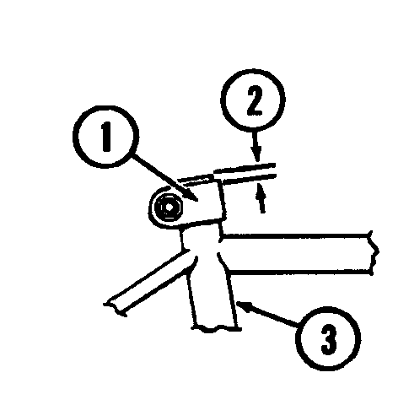

2. Assemble the reflector to the rear reflector bracket:
- Push the rear reflector bracket into the back of the red reflector.
- Make sure the stud of the red reflector goes into the hole of the rear reflector bracket.

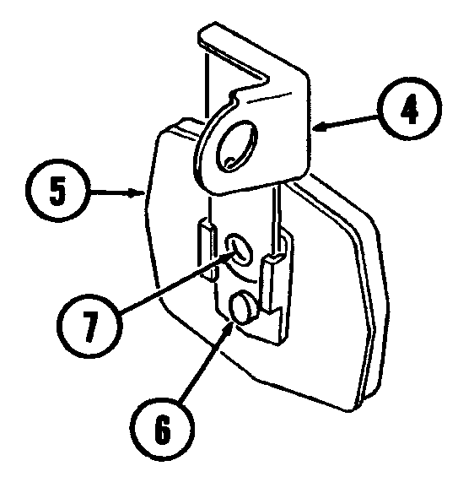

3. Assemble the rear reflector bracket to the post clamp with hardware:
- Install a bolt and nut or a quick release lever as shown below.
- Tighten the bolt and nut or quick release lever..
